Ilana's Notes #todo/work ## Key Topic 1 Figure 1 ### 7.1 Effects of Climate Change on Nature ### Draft 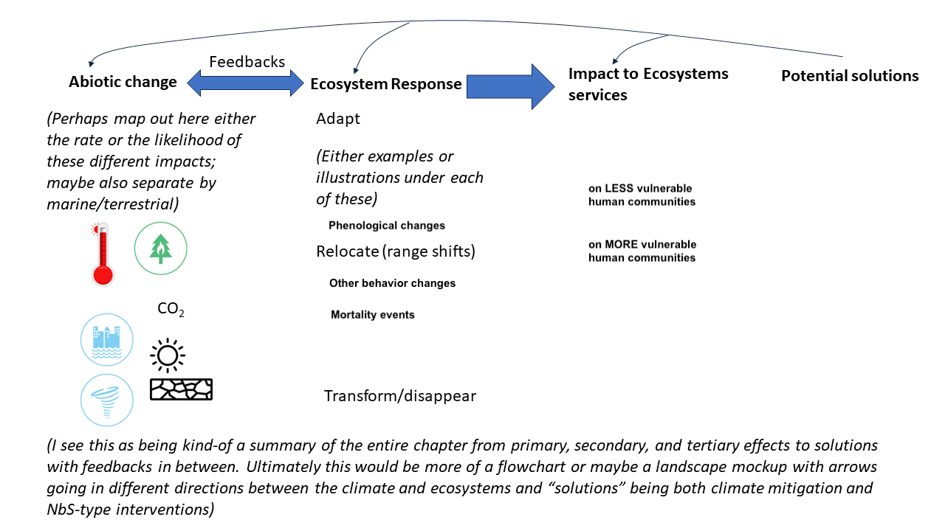 ### Notes - challenge is constraining scope enough to make it useful - if you try to capture everything it’s probably going to be a mess - focus on single example for each of these - add illustrative landscape - narrow it down and make it more clear before getting started - they don’t like flowcharts - is there a way to use one example to illustrate the others ### Action Items - [ ] Avery will get more information on authors’ intent and possible examples ## Key Topic 1 Figure 2 ### 7.2 Range Shifts and Taxa ### Draft 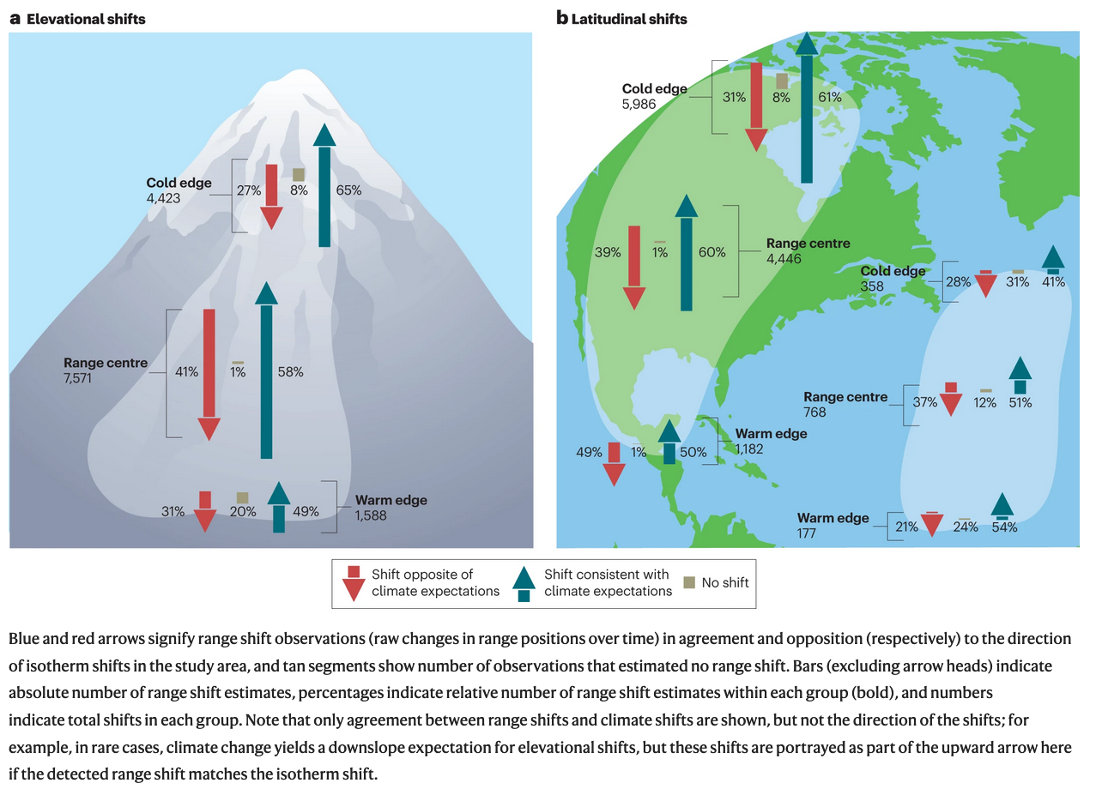 ### Notes - Want to break it down into groups of species, modifying existing figure - Need to take a look at data and see where the arrows are going - Want to make the figure look nice showing different species in the one figure - Could have some icons from previous NCA icon library - figure out which groupings of species make sense and is possible given data ### Action Items - [ ] Avery look at data by species ## Key Topic 2 Figure 1 ### 7.3 Land to Ocean Fluxes of Carbon ### Draft 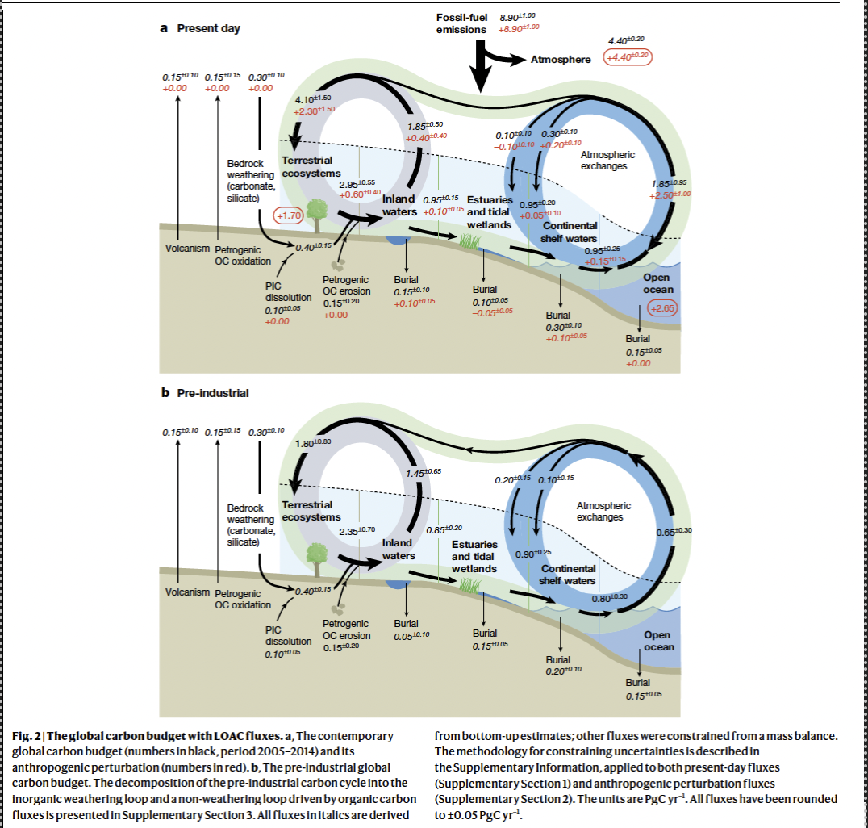 ### Notes - Add other ecosystem components, make it more of a summary - is pre-industrial vs post-industrial important to include? - Also wanting to highlight carbon cycle effects including feedbacks to CO2, CH4, N2O - Potentially including amplifiers such as methane, NOx plus climate change effects - Don’t want TOO much text, but may want some annotation ### Action Items ## Key Topic 2 Figure 2 ### 7.4 US/North America Carbon Storage, Albedo Offset, and Net Climate Impact ### Draft 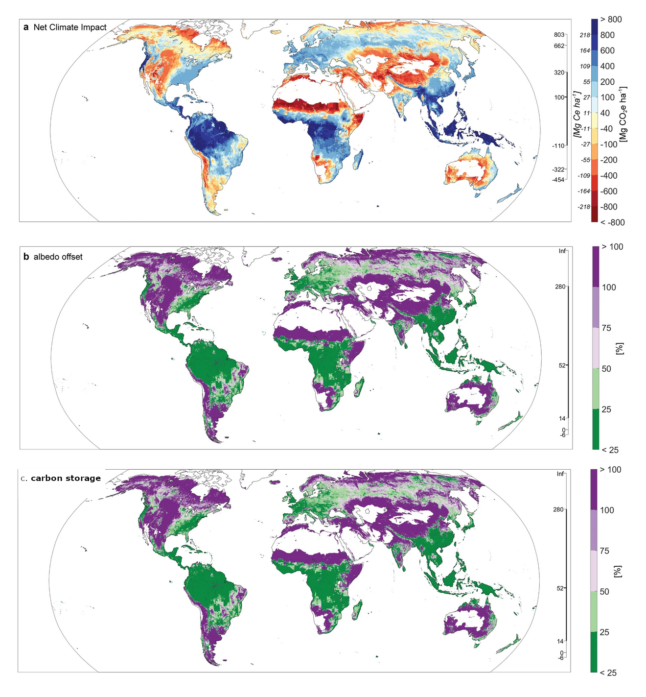 ### Notes - vectorize the raster .tif files, return US including territories Hawaii, Alaska - USGS contact - email Bonnie bmyers@usgs.com - Ambar Molinari atorresmolinari@contractor.usgs.gov ### Action Items - [ ] Convert data from data for only U.S. and U.S. territories from .tif to vector and then upload in ACE ## Key Topic 3 Figure 1 ### 7.5 Greenhouse Gas Emissions and Removal ### Draft 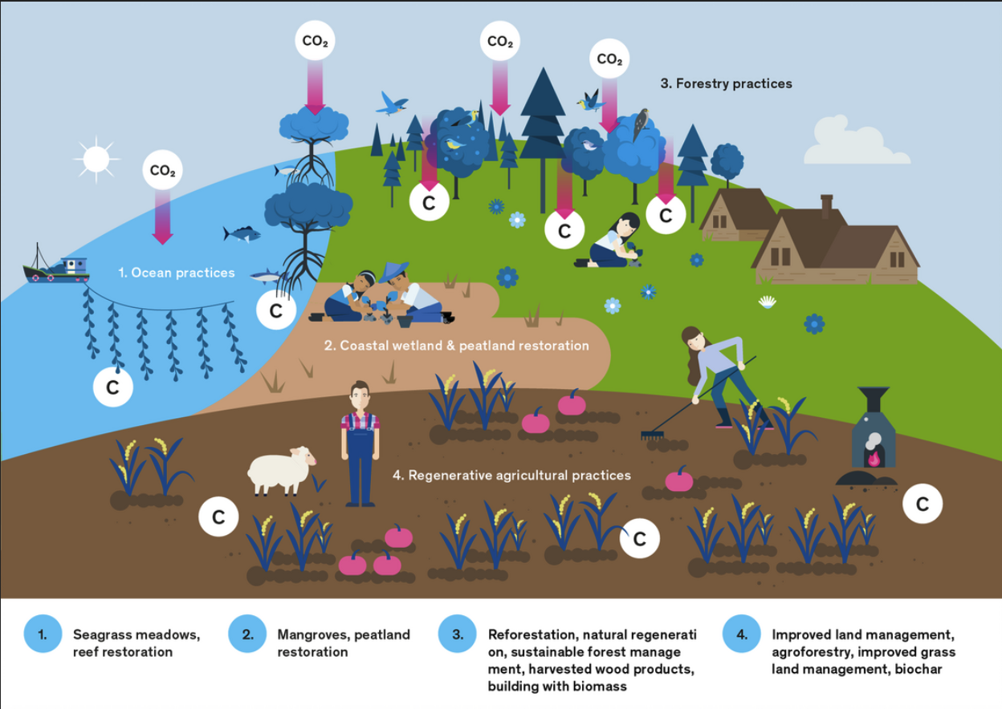 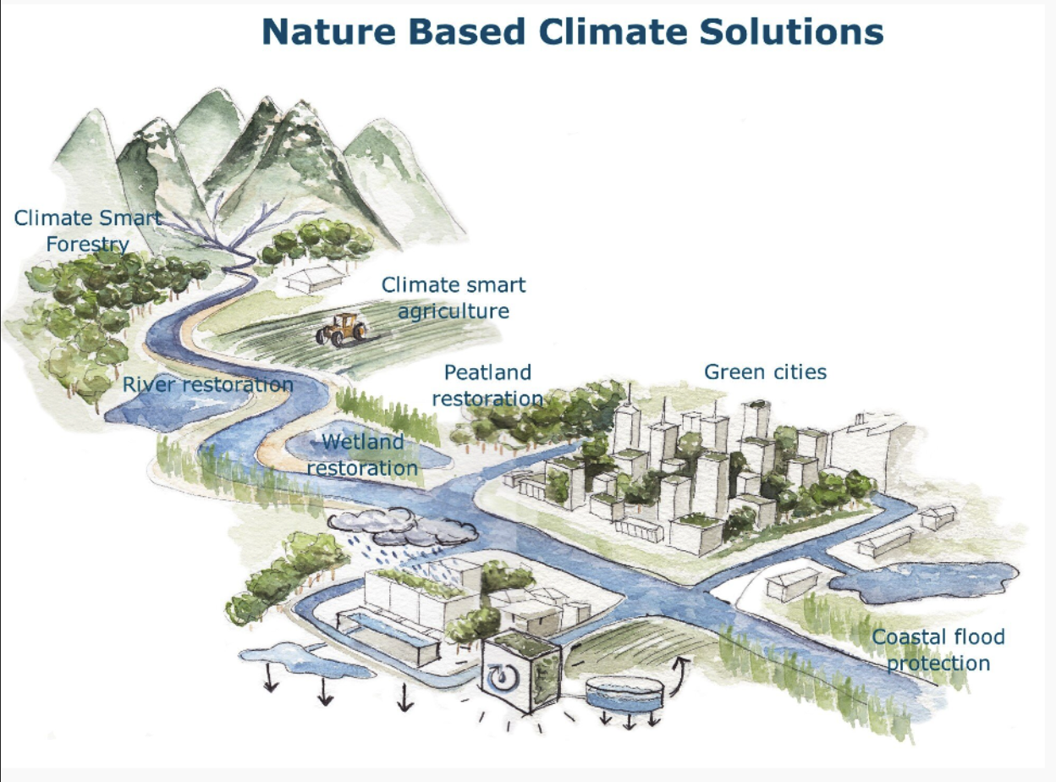 ### POC - Ailene Ettinger ### Notes - Want to also include mgmt. practices that have benefits in addition to climate benefits - Possible to have someone from the TNC create the figure, but they need to be a TC – would also need to look into copyright - TSU can also do this figure - Need for clarity on NBS vs NBcS ### Action Items - [x] Avery to check with Ailene about if TNC necessary or figure can be done by NOAA TSU ## Key Topic 3 Figure 2 ### 7.6 Natural-based Solutions and Nature-based Climate Solutions Varying Cost and Impacts ### Draft 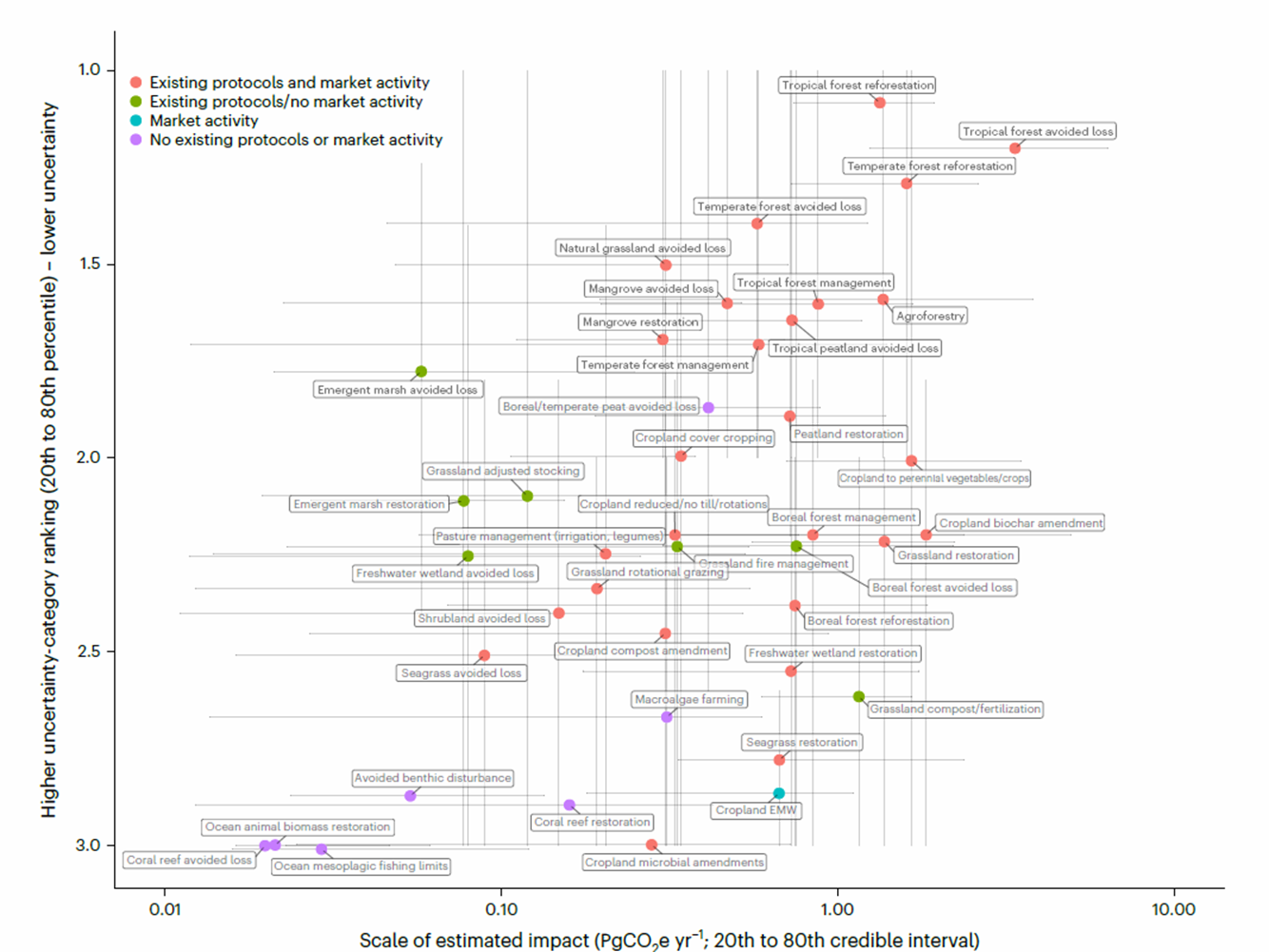 ### Notes - they like the figure - Mapping exemplary NbS on axes of estimated impact and cost, want to remap with different costs. Would need to see what data is available - Showing relationships with axis structure can work, but want to reduce text and use symbols as much as possible - Could use a legend for the axis. Will be easier for technical audience, but most other figures have been illustrative, so should be OK - Representative NbS that are important to chapter content - Conceptual graphic doesn’t have any data so would be good to pair in some way. - maybe something like this from the NCA: 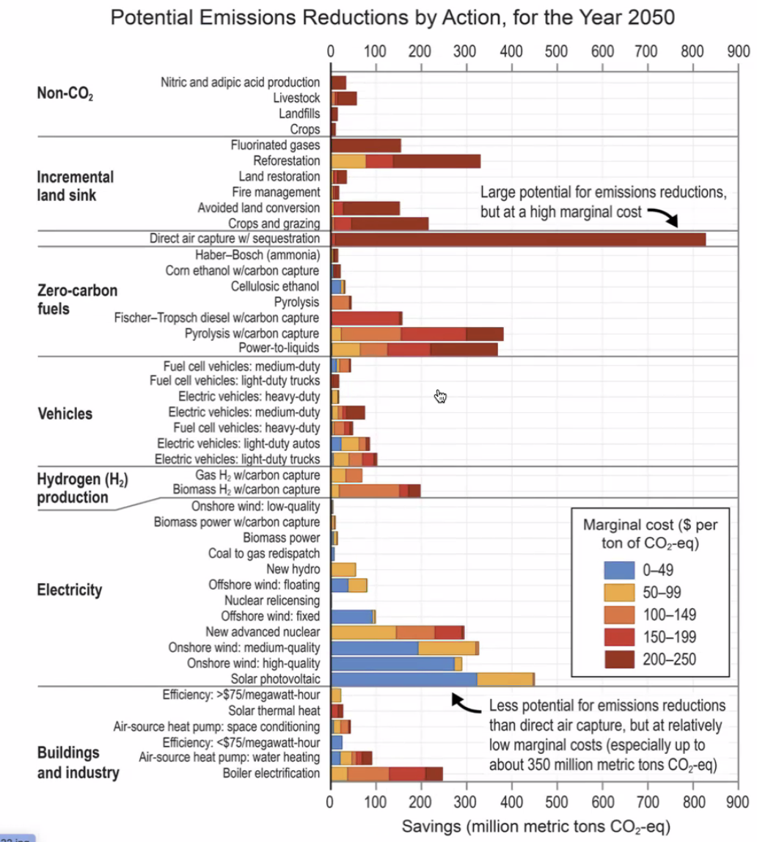 ### Action Items - [ ] Discuss important exemplary NbS with chapter - [x] Submit figure request

